CHAPTER 1: INTRODUCTION

- BACKGROUND OF THE PROJECT
In today's digital age, students receive an overwhelming number of notifications from various platforms, including messaging apps and emails. Managing these notifications becomes challenging. This leads to missed deadlines, forgotten tasks, and inefficient time management. UniDash addresses this issue by providing a centralized application to summarize and organize notifications, allowing users to focus on what matters.

PROBLEM DEFINITION

2.1 Problem Statement
The problem being addressed is the cluttered nature of notifications from different platforms, making it difficult for users to keep track of important tasks and deadlines. Without a proper system for prioritization, users may overlook critical messages, leading to reduced productivity.

2.2 Motivation for the project
The motivation behind UniDash stems from the need to create a more organized approach to handling notifications. With students and professionals juggling multiple platforms daily, a solution that combines and filters notifications will significantly enhance productivity.

- OBJECTIVES AND SCOPE OF THE PROJECT
The main objective of UniDash is to create a mobile application that aggregates and summarizes notifications from various platforms and helps users plan their tasks. The scope of the project includes:
- Fetching notifications from Google Classroom, WhatsApp, and Gmail.
- Classifying emails as either priority or spam.
- Providing a user-friendly interface to access and manage notifications.

CHAPTER 2: LITERATURE REVIEW

In researching existing solutions, we examined Apple's Task app and IFTTT.

- APPLE'S TASK APP
The Task app in iOS allows users to manage tasks manually and integrates well with Apple's ecosystem. However, it lacks the ability to automatically aggregate notifications from multiple platforms and does not use AI for summarization or prioritization.

- IFTTT
IFTTT enables users to automate workflows across apps and services through predefined "recipes." While powerful, it requires manual setup for each integration and does not offer intelligent task scheduling or summarization, which can become time-consuming.

- THE NEED FOR A MORE ABSTRACT APPROACH
UniDash addresses the gaps in these solutions by providing automatic notification aggregation. This allows for intelligent summarization from platforms like Gmail and Google Classroom, offering a more efficient and abstracted user experience without manual setup.

CHAPTER 3: SYSTEM ANALYSIS

- FUNCTIONAL REQUIREMENTS:
The functional requirements of UniDash include the core features that enable efficient notification management:

i) CRUD Operations for User Accounts:
  - Create: The system must allow new users to create accounts by registering with their email or Google accounts.
  - Read: Users should be able to view and manage their profile information and settings.
  - Update: The app should provide users the ability to update their account details, such as name, email, or password.
  - Delete: Users must be able to delete their account, removing all stored data associated with it.
ii) Fetching Emails and Google Classroom Notifications:
UniDash must integrate with the Gmail and Google Classroom APIs to fetch emails and notifications from these platforms in real time.
iii) Binary Classification for Emails:
The system should classify emails using a binary classification model, distinguishing between “priority” and “optional” messages to help users focus on the most relevant information.

- NON FUNCTIONAL REQUIREMENTS:
The non-functional requirements of Uni-Dash include the external features that enable efficient resource management and task scheduling:

i) Performance Requirements:
  - Latency: Notification fetching and classification should occur within a few seconds to ensure real-time updates.
  - Scalability: The system should handle multiple concurrent users without significant performance degradation, especially during peak times like the start of the academic day.
ii) Usability Requirements:
  - User Interface: The app should be intuitive, with a clean design that allows easy navigation between notifications, settings, and other core features.
iii) Reliability Requirements:
  - Backup and Recovery: Data should be backed up regularly, with an option for users to recover their account if they accidentally delete it within a specified grace period.
CHAPTER 4: TECHNOLOGY STACK

- LIST OF LANGUAGES, FRAMEWORK AND TOOLS USED

SkyMeet project employs a range of technologies for both the mobile application and machine learning components:

Table 4.1 Languages, Framework and Tools Used
Sr no. | Tool used | Type of tool
1 | Flutter | SDK
2 | Dart | Programming Language
3 | Python | Programming Language
4 | TensorFlow | Python Module
5 | Flask | Python Module
6 | Firebase | BAAS(Backend as a Service)
7 | Android SDK | Development Kit
8 | Visual Studio Code | IDLE
9 | Java | JDK
10 | Jupyter Notebook | Python Module

Table 4.2 Apis Used
Sr no. | Name of API | Reference/Documentation
1 | Google Classroom | https://developers.google.com/classroom/reference/rest
2 | Gmail | https://developers.google.com/gmail/api/guides
3 | Firebase | https://firebase.google.com/docs/reference/kotlin/packages

- EXPLANATION OF WHY THESE TOOLS WERE SELECTED:

i) Flutter SDK is the heart of this project, it is the most powerful, scalable and easy to use SDK to build cross platform applications. Also with support from the developer community, any issue that we faced was solved with the community’s expertise. The app's user interface and backend logic are written in Dart, ensuring high performance and responsiveness across devices.

ii) Python and TensorFlow for machine learning: Python is recognised as the go-to language for mathematical computations, so it is best suited for machine learning algorithms. Vansh had experience working with python before so he opted to work along with James on the machine learning binary classification problem.

iii) Flask Server for hosting the model: We couldn't load the trained classifier model in the app as it would use every mobile's resources and would be time consuming. Since this isn't a publicly released application, we decided to use a local server. Basically we would set up a get and post method server which would interact with the app asking for a request, which would be the email which had to be classified as priority or spam. After predicting the required number of request emails, it would send back the prediction data to the app, based on the prediction score, the app would segregate the email in either priority (1) or spam (0).

iv) Firebase provides the backend services for user authentication and database management. It handles user sign-up, login, and stores user data such as profiles and tasks. Firebase’s real-time database ensures data persistence, even after the app is closed.

v) The Android SDK enabled Flutter to easily make android applications without any configurations or set up. We also needed to use Android Virtual Devices to test the apk for debugging

CHAPTER 5: SYSTEM DESIGN

- USE CASE DIAGRAM
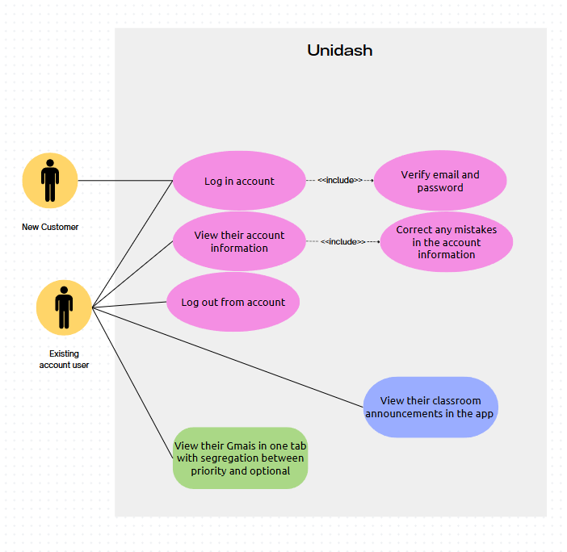
Fig 5.1 Use Case Diagram

- ARCHITECTURE DIAGRAM
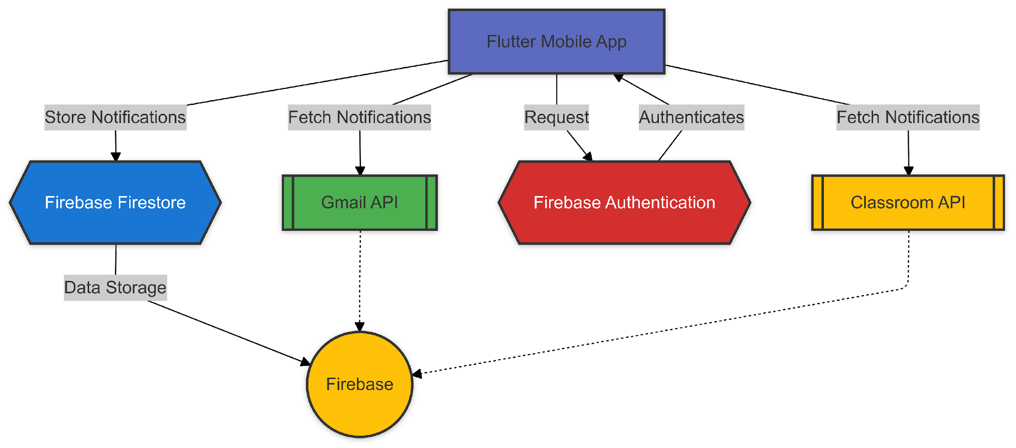
Fig 5.2 Architecture Diagram
CHAPTER 6: IMPLEMENTATION

- MODULES/COMPONENTS OVERVIEW
The UniDash project is structured into various modules and components, each responsible for specific functionality:
1.1 Authentication Module
This module handles user sign-up, login, and account management using Firebase Authentication. It ensures secure access to the app and stores user credentials.
1.2 Notification Fetching Module
This module integrates with the Gmail and Google Classroom APIs to fetch email and class notifications. It processes incoming notifications and prepares them for classification.
1.3 Email Classification Module
The email classification component uses a binary machine learning model (hosted via a Flask server) to distinguish between priority and non-priority emails. This helps filter out irrelevant emails, providing users with focused notifications.
1.4 User Interface Module
Built with Flutter, this module handles the entire front-end of the app. It includes screens for logging in, viewing notifications, managing tasks, and updating user profiles.

- FEATURES DEVELOPED
2.1 User Authentication
  - Firebase Authentication enables users to securely create and manage accounts.
  - Support for login via email or Google accounts.
2.2 Notification Fetching
  - Integration with Gmail and Google Classroom APIs to fetch email and class notifications.
  - Periodic background syncing to ensure up-to-date notifications.
2.3 Binary Email Classification
  - Emails are classified as either priority or non-priority using a machine learning model.
  - Helps users focus on important information and ignore irrelevant messages.

- CODE SNIPPETS:

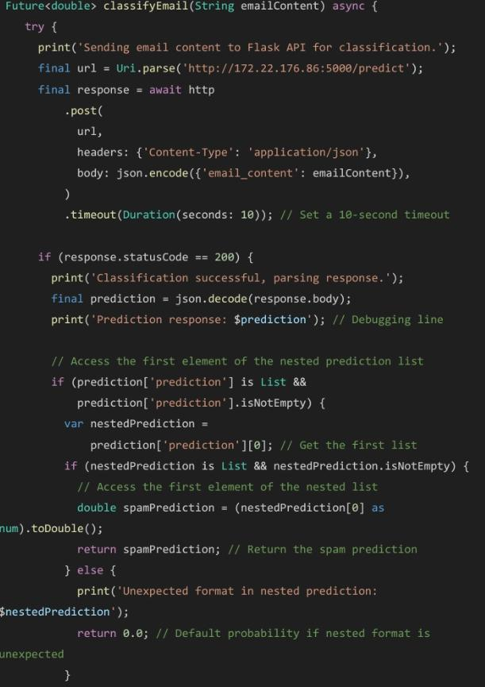
Fig 6.1 Fetch and classifying emails from gmail api

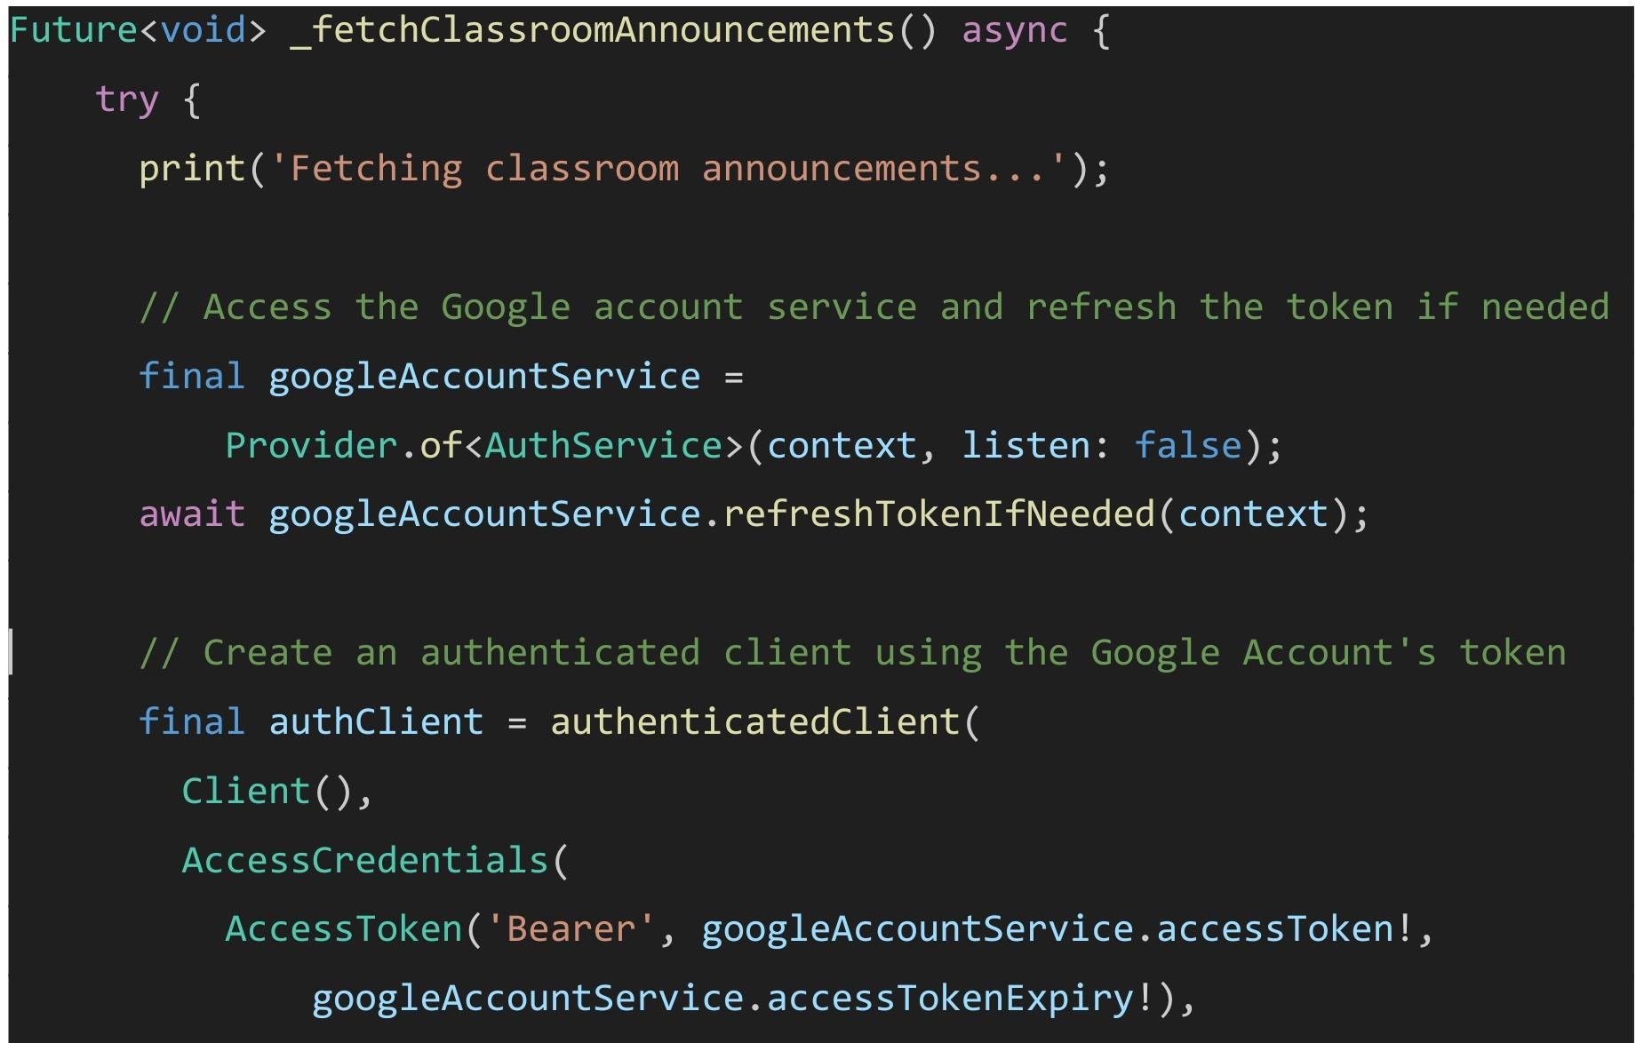
Fig 6.2 Fetch Announcements From Classroom Api

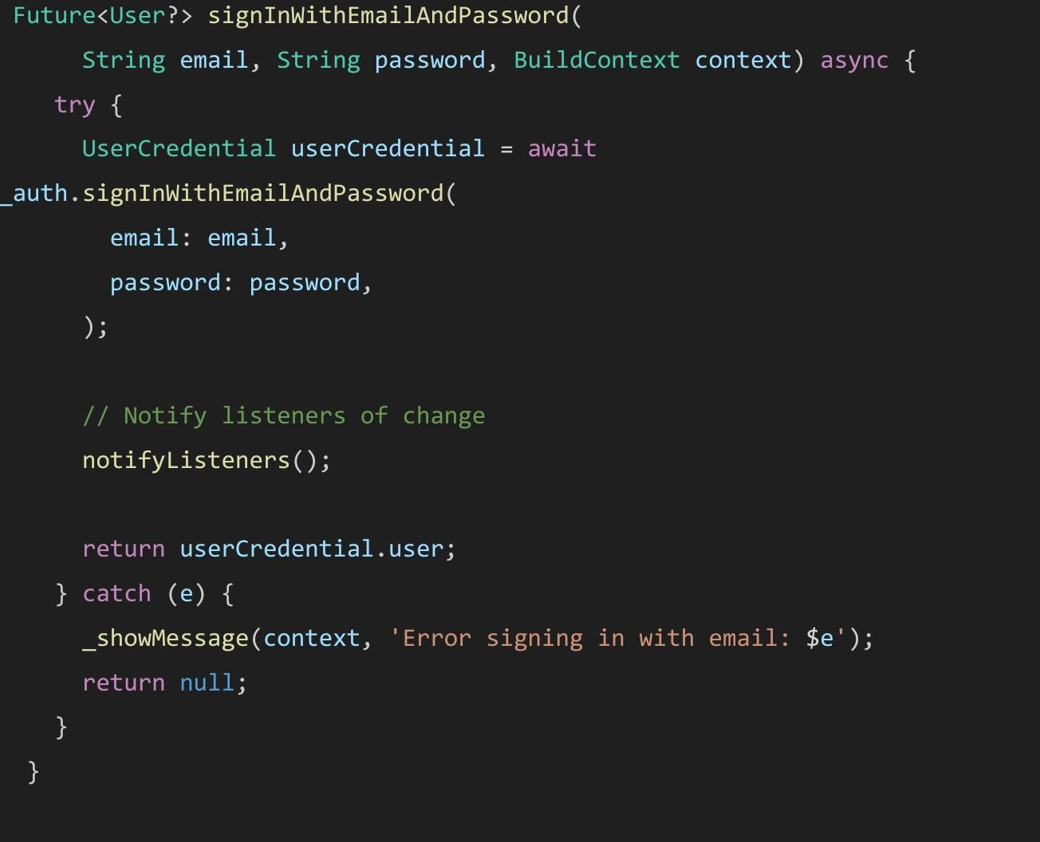
Fig 6.3 Sign In Using Email And Password
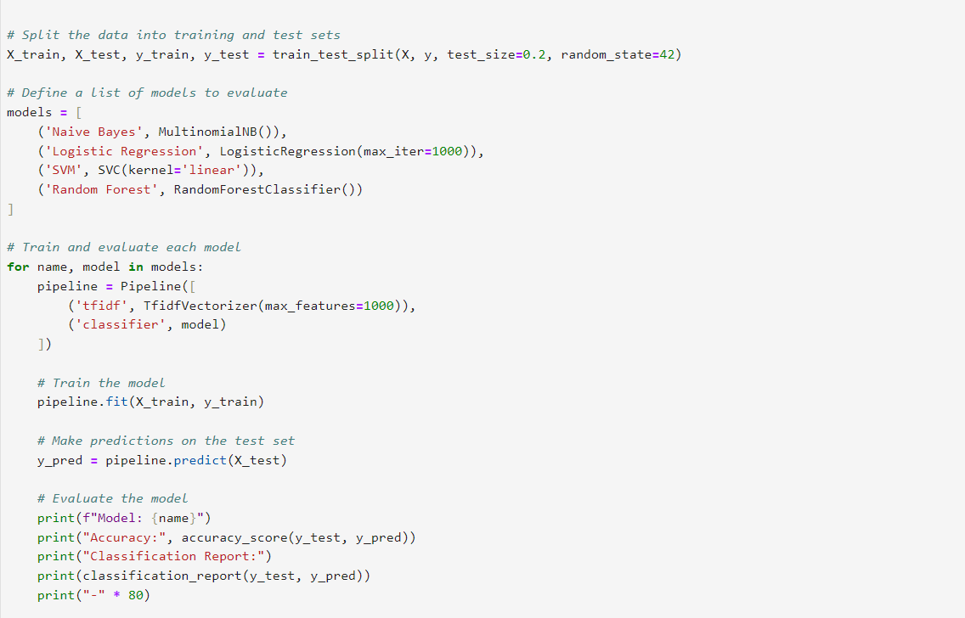
Fig 6.4 Model Training in Jupyter Notebook

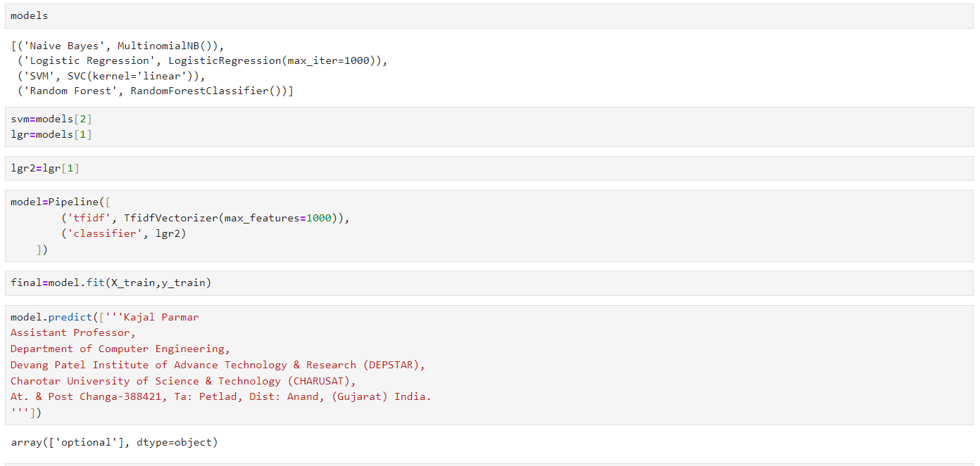

Fig 6.5 Model Prediction For Sample Text

CHAPTER 7: RESULTS

- SCREENSHOTS OF THE FINAL PRODUCT
The final product is a mobile application of which we have attached screenshots of every screen from startup to homescreen.

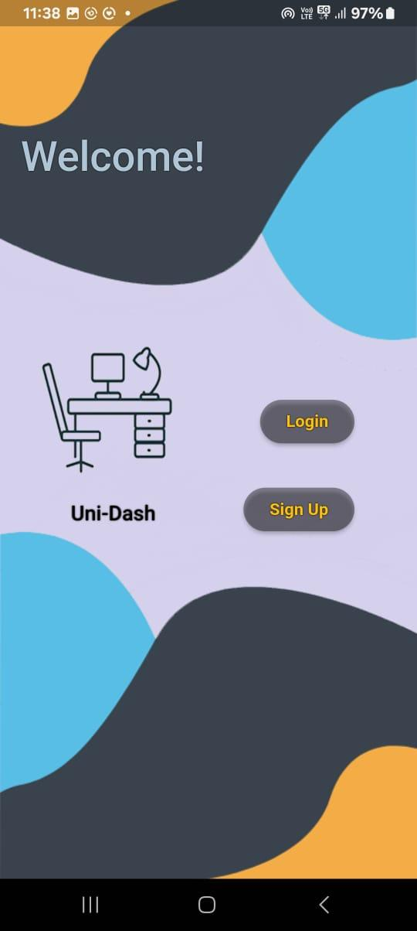

Fig 7.1 Welcome Screen

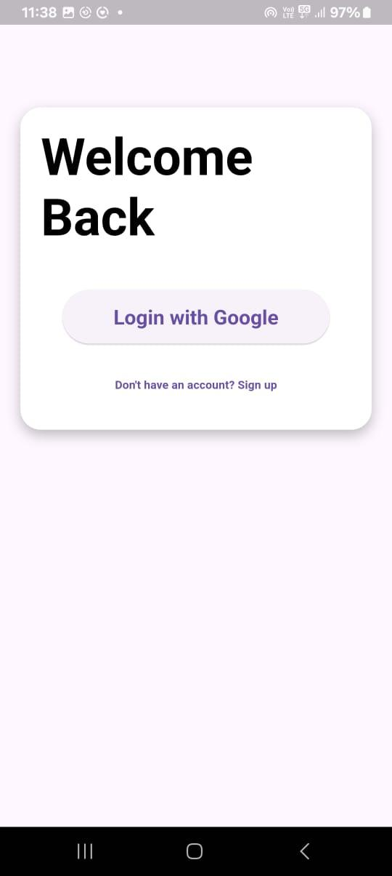

Fig 7.2 Login Screen

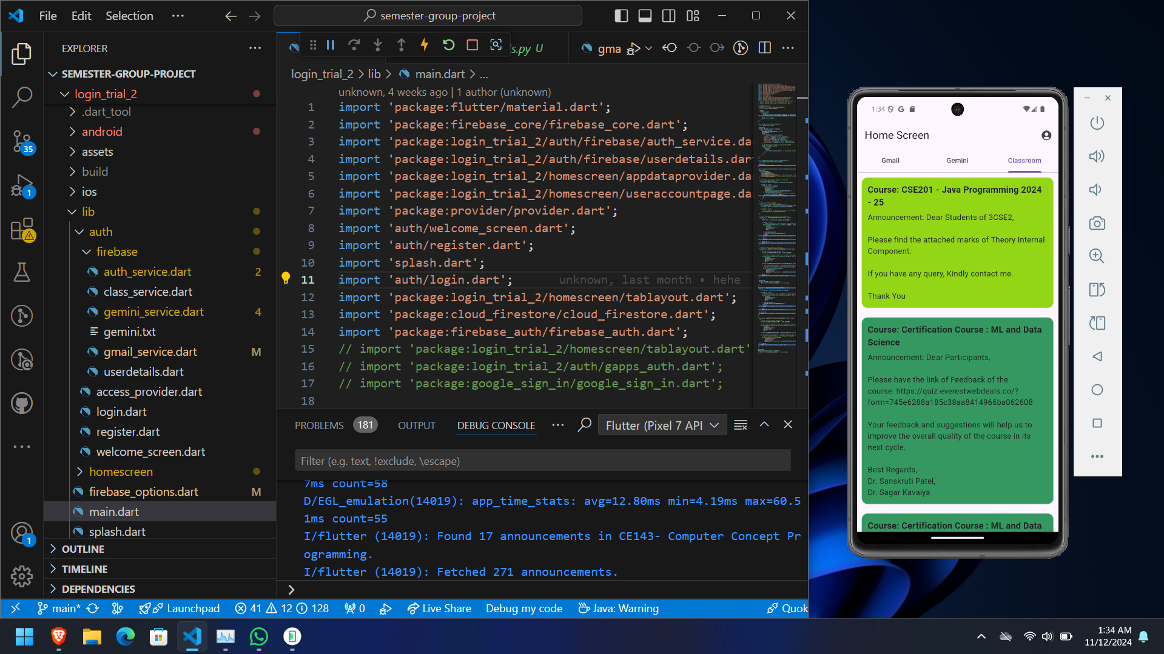
Fig 7.3 Classroom Tab of the Application

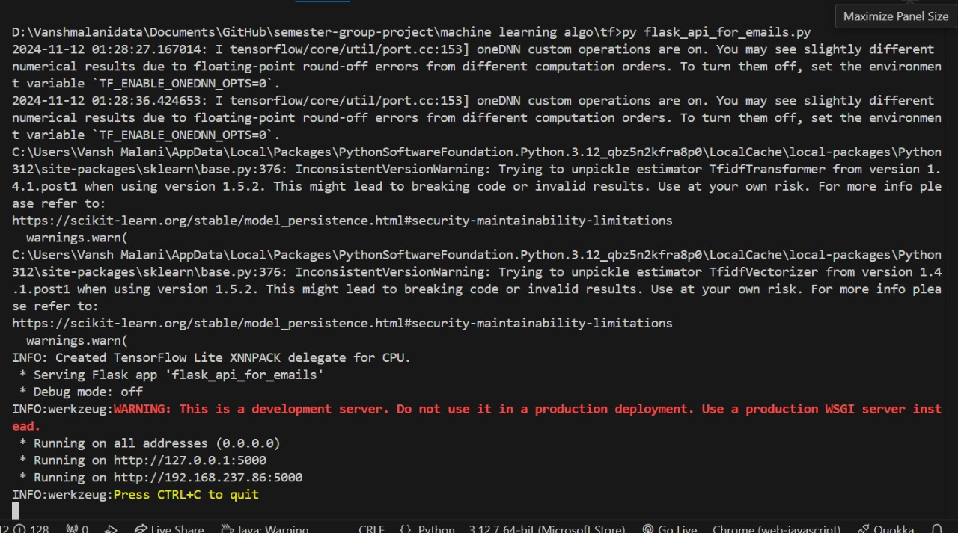
Fig 7.4 Flask Server on Local Server

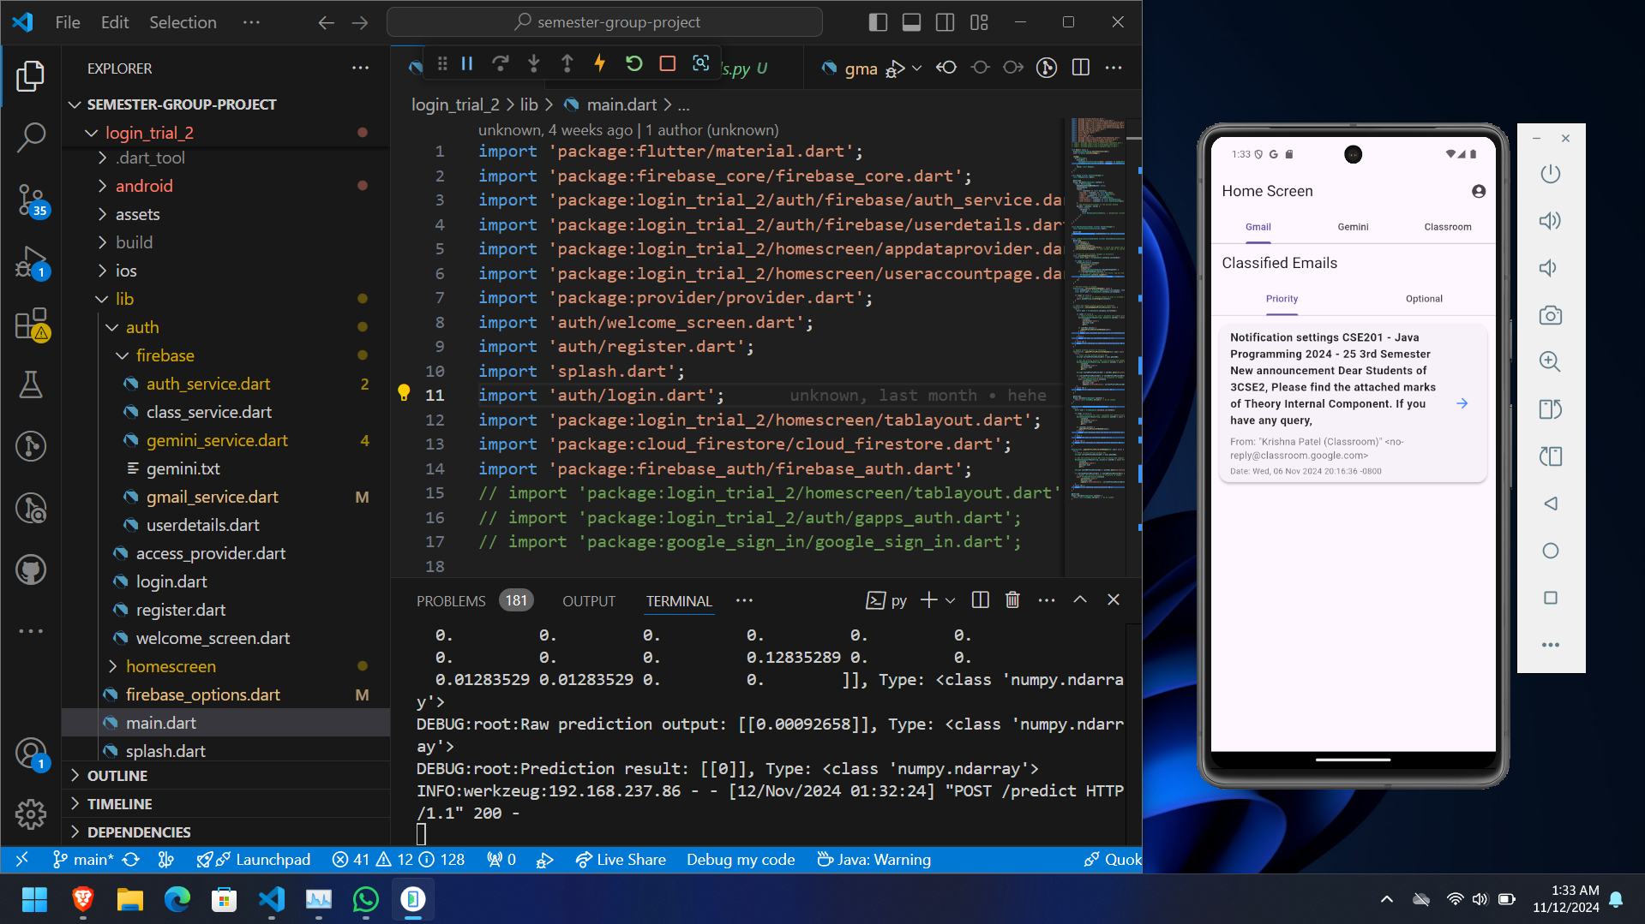
Fig 7.5 Priority Emails Classified

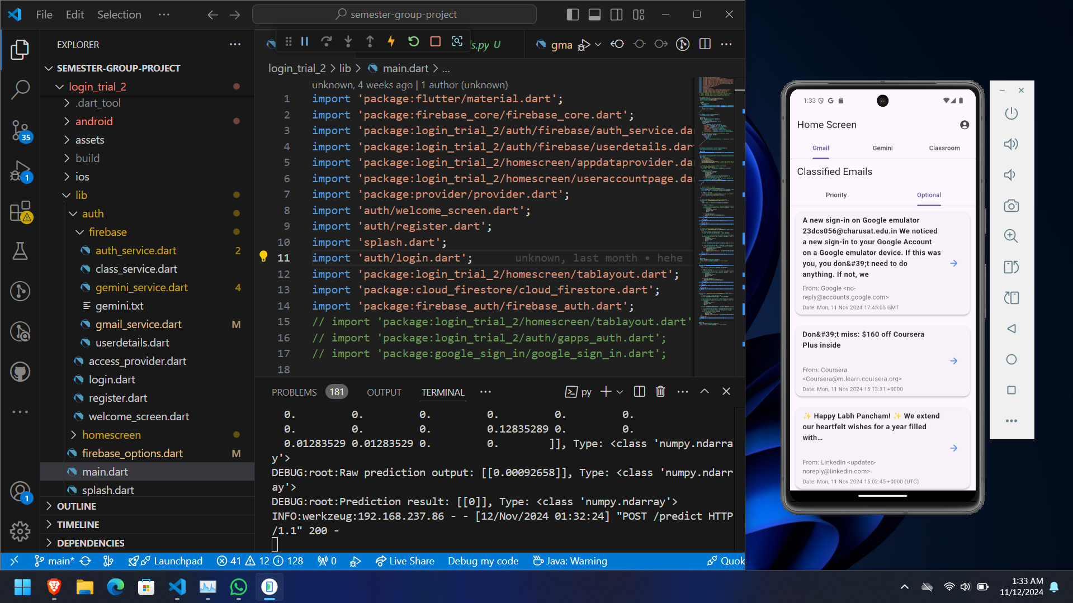Fig 7.6 Spam Emails Classified

- EXPLANATION OF THE FUNCTIONALITY ACHIEVED.

- We have implemented Binary Classification using Keras Sequential Model and a TF-IDF vectorizer to convert the text in machine code matrices and then label the data as optional or priority. Then we trained the defined model on the data. After we reviewed the accuracy of the model, we exported it as a Tf-lite model so that it uses less system resources to run.
- The next step was to run the model when the app fetches the data. It could be done by either packaging the model with the app built in flutter and running it on the user’s device, but it would consume system resources and would be laggy. A better approach would be to host the model on a server and send requests to it from the app. We decided to locally host the server via a flask module in python and load the model in it. From the client side, it would send the content of the email to the model and the model would predict the label for it and send it back to the client and this way the machine learning algorithm would work.
- The next functionality achieved was the app’s ability to fetch classroom announcements and display them via color coding according to the courses. This was possible because at the login screen, when the user gave the app access to the google account, it asked for the following permissions:
access to courses in google classroom
access to announcements in google classroom
access to rosters (teachers) in google classroom

These permissions allowed us to fetch the information required and display it in an interactive manner.

CHAPTER 8: Challenges Faced

- DEVELOPMENT CHALLENGES FACED
During development, the following challenges were faced by the team:
- Setting up Firebase sdk with the application: manually setting up firebase sdk with the application was a hassle as it required us to modify the build settings and also work with Gradle and kotlin properties.
- Setting up the google cloud platform for the application: setting up the required apis for our application for the first time was definitely challenging.
- making the application’s front-end: With no experience in front-end development. our teammates had some difficulties choosing the perfect color scheme, the button placements and view of the application

- SOLUTIONS OR WORKAROUNDS USED

To solve the challenges faced by the team, the following workarounds were used
- Setting up Firebase sdk with the application: we scoured the internet for a solution, which is when we came across an automation tool which helped us get through this step with ease. This tool is named “flutter-fire” which is available in npm (node package manager). It is a CLI which helps us automate the task of setting up Firebase with flutter projects.
- Setting up the google cloud platform for the application: We first tested the working of the api using a python script for fetching some emails and classroom notifications from our own gmail accounts. Once we confirmed that the apis were working as intended, we used similar scripts in the main application code and defined our parameters to how we want to fetch the data from the respective service.
- Making the application’s front-end: before getting into our projects front-end development, two of our members, James and Jugvi, were given the task of designing a whatsapp clone in flutter by watching a YouTube tutorial from scratch. This gave them the know-how and knowledge of the tags and attributes available in flutter and also gave them a sense of understanding for the color scheme they had to work on and decide for the app.

CHAPTER 9: Conclusion and Future Scopes

- SUMMARY OF THE PROJECT ACHIEVEMENTS
UniDash solves the problem of managing notifications from multiple platforms in a simple way. Using AI models for summarizing and sorting messages, the app makes it easier for users to stay organized and focused. The project shows how APIs, machine learning, and Flutter can work together to create a useful, cross-platform app.

- POTENTIAL AREAS OF IMPROVEMENT OR FUTURE FEATURES:
2.1 Expand Platform Support:
- Incorporate additional platforms like Teams or Zoom for notifications
- Working on an IOS Application.
2.2 Improved Summarization Models:
- Explore more advanced LLMs like GPT-4 for even better summarization.
2.3 Offline Functionality:
- Implement offline storage to allow users to view tasks even without an internet connection.
2.4 Customizable Notifications:
- Add support for personalized filters and notification priorities.

References
Flutter SDK: https://docs.flutter.dev/
FlutterFire CLI: https://firebase.flutter.dev/docs/cli/
Flask Python: https://flask.palletsprojects.com/en/stable/
TensorFlow: https://www.tensorflow.org/
Jupyter Notebook: https://jupyter.org/try
Binary Classification using tensorflow: https://www.freecodecamp.org/news/binary-classification-made-simple-with-tensorflow/
Building Flutter Apps from Scratch: https://www.freecodecamp.org/news/how-to-develop-a-flutter-app-from-scratch/
Google Sign-In Tutorial Flutter: https://github.com/nisrulz/flutter-examples
Firebase SDK: https://firebase.google.com
Flutter Splash Screen Examples: https://github.com/samarthagarwal/FlutterScreens
FIrebase connection with Flutter: https://firebase.google.com/codelabs/firebase-get-to-know-flutter#0
Google Cloud Console: https://console.cloud.google.com/
Gmail API: https://googleapis.dev/nodejs/googleapis/latest/gmail/classes/Gmail.html
Classroom API: https://developers.google.com/classroom/reference/res

